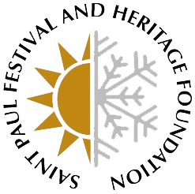

Dear Vendor,
The Saint Paul Festival and Heritage Foundation, a 501(c)(3) non-profit organization and proud producers of the Saint Paul Winter Carnival and Cinco de Mayo – West Side Saint Paul, is well underway in another successful year of events. While we are preparing for another exciting year of the Winter Carnival, we are also developing an exciting new fundraiser: Royally Flushed Casino Night! This brand-new evening event will offer guests an opportunity to bid on great items in our silent auction, participate in casino games, sample food from local restaurants, and enjoy the company of Foundation members and supporters.
Royally Flushed Casino Night will be held on Friday, November 16th from 5pm to 8pm at the Midpointe Event Center at 415 Pascal Street North, St. Paul, MN 55104. The evening is the perfect opportunity to showcase your goods and promote your business while supporting the Saint Paul Festival and Heritage Foundation and its mission to serve the community. The Saint Paul Festival and Heritage Foundation will also contribute to the promotion and exposure of your business via our social media platforms that amass over 30,000 followers. Your commitment to this event provides you with a unique opportunity to introduce your business to a group of dedicated festival enthusiasts and the broader Saint Paul community in November.
We invite you to take part in the event by donating product to be served throughout the event. We will supply all service through our event bars, so there is no need to provide staff for the event. Additionally, we will distribute a piece of advertisement to all attendees for you during the event.
Proceeds from this event support the operational budgets of the 2019 Saint Paul Winter Carnival and 2019 Cinco de Mayo - West Side Saint Paul. To join us at this exciting event, please complete the enclosed vendor form so proper recognition can be made. If you have any questions, please contact Alyssa Olson at (651) 223-7400 or aolson@spfhf.org.
Thank you for your support of the Saint Paul Festival and Heritage Foundation and its mission to serve the Saint Paul community. We look forward to working with you.

Sincerely,

Alyssa Olson Deb Schaber
Marketing & Event Manager, SPFHF President/CEO, SPFHF

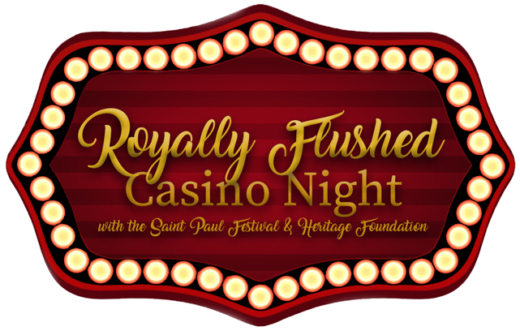
The Saint Paul Festival and Heritage Foundation will be hosting a new fundraising event, Royally Flushed Casino Night, with opportunities to serve food, wine and beer tastings on Friday, November 16 from 5:00pm to 8:00pm at the Midpointe Event Center at 415 Pascal Street North, St. Paul, MN 55104. The evening will be filled with entertainment, a silent auction, casino games and much more! The proceeds raised at this event will support the upcoming Saint Paul Winter Carnival and Cinco de Mayo - West Side Saint Paul.
We are asking for your help in the form of donated product to make this event a success! By donating to this event, your generous contribution will be recognized in event publications, programs, social media and our website.

To highlight your business during this inaugural event, we ask for your commitment no later than November 5. SPFHF can pick up any items, as needed. Thank you so much for your generous donation!

Product Donation
Donor/Business Name___________________________________________________________________
(As preferred on any printed materials and in the event program)

Contact Name(s): ______________________________________________________________________

Address: ______________________________________________________________________________

Telephone: ________________________ Email ______________________________________________

Website Address: _______________________________________________________________________

Item(s) being served: ____________________________________________________________________

(Comments or additional information)

Email completed form and preferred logo to Alyssa Olson at aolson@spfhf.org by November 5. If you need product to be picked up, please request by November 9.

